

Fortna Inc.

Buttonwood

West Reading, PA

Software DDD Print and Apply Fallback
Document Version: 0.6
Date: 5/18/2011

This page intentionally left blank.
Table of Contents
1 Introduction 1
1.1 Document Objective 1
1.2 References 1
1.2.1 Participants included: 1
1.2.2 Documents 1
1.2.3 Code 1
1.3 Document Conventions 1
1.3.1 FortnaPlus Code Definitions 1
1.3.2 Non-code definitions 2
1.3.3 Acronyms and Abbreviations 3
1.3.4 Requirements Numbering 3
2 High Level Summary 4
2.1 Conveyor System Layout 4
2.2 High Level Summary 4
3 Process Flow 5
3.1 Sorter Release 5
3.2 Print and Apply Line 5
3.2.1 Gapper. 5
3.2.2 Scanner 5
3.2.3 Printer 5
4 User Interface Screens 6
4.1 Print and Apply Fallback 6
4.1.1 Name 6
4.1.2 PA Name 6
4.1.3 Number of Printers 6
4.1.4 pStatus 7
4.1.5 pDown Printer 7
4.1.6 New Gapper 7
4.1.7 Servo Gapper 8
4.1.8 Gap Time 8
4.1.9 Pitch Time 8
4.1.10 Gap Ticks 9
4.1.11 Pitch Ticks 9
4.1.12 pConfError 9
4.1.13 pError Message 10
5 Messaging 11
5.1 Input / Output 11
6 Data Definitions 12
6.1 PrinterBoss menu 12
6.1.1 Name 12
6.1.2 AvailAssign 12
6.1.3 Enabled 12
6.1.4 PrintLine 13
6.1.5 PrinterErrorIn 14
6.2 PrintApplyLine 14
6.2.1 Name 15
6.2.2 ControlMachine 15
6.2.3 NumPrinters 16
6.3 New Gapper 16
6.3.1 Name 16
6.3.2 MinGapTM 16
6.3.3 MinPitchTM 17
6.4 Servo Gapper 17
6.4.1 Name 17
6.4.2 EnableFlag 18
6.4.3 MinTicks 18
6.4.4 MinStop 18
6.4.5 Factor 18
6.4.6 PitchFlag 19
6.4.7 MatchRecord 19
6.5 File Structure 19
6.6 PrintApplyFallback Process 19
7 Error Reporting 21
7.1 General Architecture 21
7.1.1 Startup Logs 21
7.2 Runtime Logs 21
8 Computer System 22
8.1 System Architecture 22
8.2 Real-time Performance 22
8.3 Support 22
9 Deployment and Validation Plan 23
9.1 Intent 23
9.2 Print and Apply Simulation Setup 23
9.2.1 Machine Menu 23
9.2.2 MsgMap Menu 23
9.2.3 Configure I/O 23
9.2.4 Conveyor I/O Menu 23
9.2.5 Batches Configuration 23
9.2.6 Sorter Configuration 24
9.2.7 Induct Point Menu 24
9.2.8 Divert Point Menu 24
9.2.9 Update Points 24
9.2.10 ScanStat Configuration 24
9.2.11 Print Apply Line 24
9.2.12 Printer Belt Configuration 24
9.2.13 Height/Width/Length Configuration 24
9.2.14 Printer Configuration 25
9.2.15 Printer Update Point Configuration 25
9.2.16 Test Config Line 25
9.2.17 Test Config Printer 25
9.2.18 Label Configuration 25
9.3 Print and Apply Simulation Operation. 25
9.3.1 Shifters Window 25
9.4 Client Responsibilities 26
9.4.1 Network Access 26
9.5 Deployment Strategy 26
9.6 Execution Plan 26
9.7 Verification and Validation Matrix 27

This page intentionally left blank.

Introduction
The software Functional Requirements Document details the software requirements for a Print and Apply Fallback algorithm and interface. This document is purely for internal use and must not be distributed outside of Fortna Inc.

Document Objective
The purpose of the FRD is to define the software functional specifications for the project for inclusion in the Functional Specification Document. It also will form the basis for subsequent software engineering plans as they relate to this project.

References
These requirements were gathered through meetings and other communications methods with Fortna personnel.

Participants included:
Barry Conklin
Thurman Kremser
Paul Rotter

Documents
NewGapper Module.pdf
Version 8 Misc Modules.doc

Code
The code will be documented using Doxygen comments.

Document Conventions

FortnaPlus Code Definitions
This section contains definitions for the FortnaPlus Control software code. These definitions may not match actual machinery.
Encoder | A device that indicates belt movement. A wheel connected to a belt that provides a pulse (tick) for fixed distance the belt moves.
New Gapper | A virtual device that creates gap. It is composed of a fixed speed belt feeding into a second fixed speed belt. A gap is created by stopping the first belt for a period of time.
Servo Gapper | A virtual device that creates gap. It is composed of a servo controlled (variable speed) belt feeding a fixed speed take away belt. A gap is created by slowing the servo belt.
Shifter | A shifter is a virtual device created from a belt and an encoder. It is used to track the position of a container.
Shifter Count | The shifter count is the position of the container in encoder ticks from the start of the belt/shifter.
Sorter | A virtual device that decides actions. The Sorter requests events from the Shifter based on a Container’s position. The Shifter will track a Container on each tick while a Sorter only needs to know when a Container reaches a particular position. Once a Container reaches a particular position the Sorter is responsible for trigger an action on the Container.

Non-code definitions
Container | a general term used to describe cartons or totes that can be conveyed by the system
Encoder | A device that indicates belt movement. A wheel connected to a belt that provides a pulse (tick) for fixed distance the belt moves.
Gap | The distance between tail of a Container and the nose of next Container.
Gapper | A device that creates distance between containers.
Pitch | The distance between the nose of a Containera and nose of the next Container.
Sorter | A device that separates containers. Maybe.

Acronyms and Abbreviations

Requirements Numbering
Throughout this document, a requirement number will follow any requirement specified. This is done to help identify the functional area associated with the requirement and to identify the requirement for testing purposes.

These requirement numbers are of the following form: REQ-XYZnnn.
REQ - identifies this as a requirement
XYZ - identifies the functional area of the requirement (e.g. DB = database, GUI = graphical user interface, PRF = processing function, etc.)
nnn - unique identification number

High Level Summary

Conveyor System Layout

Sorter
Printers
Scanner
Gapper
PC
PC
PC
PC

High Level Summary
The goal of the Print and Apply Fallback design is to create a fault tolerant printing system. The system consists of a sorter, one or more printer lines, and a controlling PC. Each printer line contains a Gapper, a Scanner, more than one Printer, and a controlling PC. The Print and Apply system will be able to fully utilize all the printers at full speed during normal operation. If a Print and Apply Line printer generates a fault, the system will reduce volume of produce flowing on to the line and the Gapper will generate a variable sized gap so the remaining printers will operate correctly.

Process Flow

Sorter Release
During normal operation the Sorter will release a set volume of product into each Print and Apply Line. In the event of a printer failure, the Gapper on the Print and Apply Line will increase the gap between containers. This will slow the uptake of the Print and Apply Line. To prevent excessive recirculation on a Sort, the Sorter’s input gap will be increased. This operation will be described in a separate document. Note: The input lane of the Print and Apply Line may fill and become blocked.

Print and Apply Line
The stages of the Print and Apply line are.

Gapper.
The Gapper will create a gap or pitch based on the number of working printers. The menu will have a gap size based on the number of available printer to take into account difference between printers. This option is simple but many unnecessary reduce the capacity of the line if there is a mix of fast and slow printers.
Second option: Give each printer a capacity and scale the gap based on the capacity of the remaining printers. This option is more complicated and maybe unnecessary. Do clients run mixes of printers?

Scanner
The Scanner is located after the Gapper and will scan each container. The data is sent to Level 2 to determine which label should be applied by the printer. The time required to scan a container, communicate to Level 2, and send the data to the printer needs to be considered in the distance between the Scanner and the set of Printers.

Printer
The Printer applies the label specified by the database lookup.

User Interface Screens
A PC will be provided at each of the Print and Apply lanes for supervisory control. The following setup screens are defined:

Print and Apply Fallback
The Print and Apply Fallback menu will be located under Configuration Menu…->PrintApply Utilities…->Print Apply Fallback. The following columns will be defined.

Name
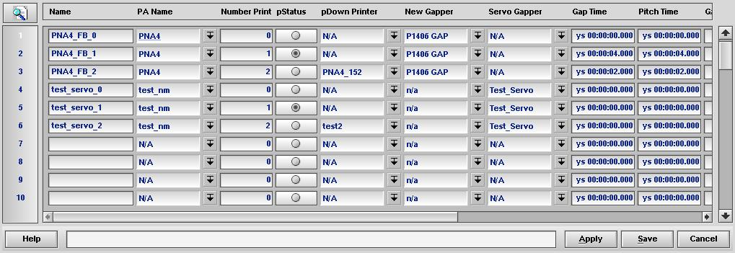
The “Name” column is the Print and Apply Fallback configuration name. The column type is STRING. The first column in all menus should be Name and of type STRING. This allows the menu to be uses as a pop-up in another menu.

PA Name
The “PA Name” column is the name of the Print and Apply line. The column type is ‘POP-UP SELECTION UNIQUE’ with the PopUpMenu set to ‘PrintApplyLine’. The configuration for multiple Print and Apply Lines can be set in the Print and Apply Fallback menu.

Number Printers
The “Number of Printers” column specifies the number of active printers on the line. The type should be “INTEGER” and should go from 0 to the maximum number of printers on the line. All numbers from 0 to the maximum number of printers needs to be set. Zero is assumes the line is stopped.

pStatus
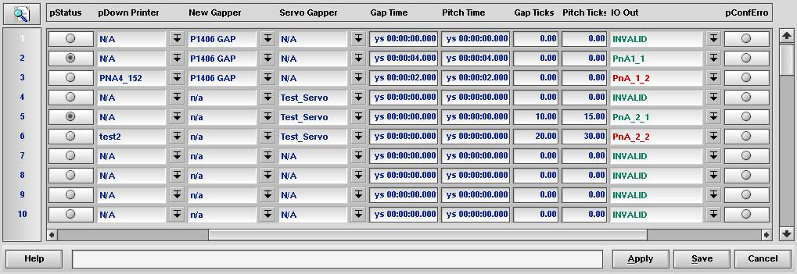
The “pStatus” column indicates which row is being actively used. The type will be 36. The column indicates to the user which configuration is active. The field is to indicate status and is not configurable. Only one pStatus field row will be set for a single Print and Apply Line.

pDown Printer
The “pDown Printer” column indicates the out of service printer. The column type is ‘POP-UP SELECTION UNIQUE’ with PopUpMenu set to ‘PrinterBoss’. The column is not configurable. The pDown Printer field will be empty during normal operation. When a printer fault is detected the down printer field on the highest “Number of Printers” row will be set to the name of the out of service printer.

New Gapper
The “New Gapper” column sets which Gapper the Print and Apply Line controls. The column type will be ‘POP-UP SELECTION UNIQUE’ with PopUpMenu set to ‘NewGapper’. Note: If a New Gapper is selected then a Servo Gapper should not be selected. It is assumed that a Print and Apply Line has a single Gapper. All rows should have the same New Gapper for a Print and Apply Line. A configuration error will be indicated if both the New Gapper and Servo Gapper columns are N/A or if both are filled.

Servo Gapper
The “Servo Gapper” column controls which Servo Gapper the Print and Apply line is connected to. The column type will be ‘POP-UP SELECTION UNIQUE’ with PopUpMenu set to ‘ServoGapper’. Note: If a Servo Gapper is selected then a New Gapper should not be selected. It is assumed that a Print and Apply Line has single Gapper. All rows should have the same Servo Gapper for a Print and Apply Line. A configuration error will be indicated if both the New Gapper and Servo Gapper columns are N/A or if both are filled.

Gap Time
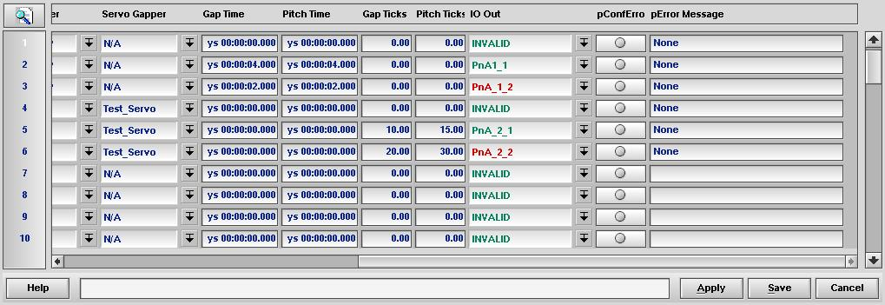
The “Gap Time” column indicates the desired gap time for a New Gapper. The column type will be ‘DOUBLE AS TIME ELAPSED’. It is expected that the Gap Time will increase as the number of printers decrease. Note: Currently this only adjusts the Gap Time for a New Gapper. In the future other time based Gappers may use this. A configuration error will be indicated if the Gap Time is 0 for a configuration with one or more printers.

Pitch Time
The “Pitch Time” column indicates the desired pitch time for a New Gapper. The column type will be ‘DOUBLE AS TIME ELAPSED’. It is expected that the Pitch Time will increase as the number of printers decrease. Note: Currently this only adjusts the Pitch Time for a New Gapper. In the future other time base Gappers may use this field. A configuration error will be indicated if the Pitch Time is 0 for a configuration with one or more printers.

Gap Ticks
The “Gap Ticks” column indicates the desired gap in ticks for a Servo Gapper. The column type will be ‘DOUBLE’. It is expected that the Gap Ticks will increase as the number of printers decreases. Note: Currently this only adjusts the number of Gap Ticks for a Servo Gapper. In the future this may control other Gappers that are configured using ticks. A configuration error will be indicated if the Gap Ticks are 0 for a configuration with one or more printers.

Pitch Ticks

The “Pitch Ticks” column indicates the desired pitch in ticks for a Servo Gapper. The column type will be ‘DOUBLE’. It is expected that the Pitch Ticks will increase as the number of printers decreases. Note: Currently this only adjusts the number of Pitch Ticks for a Servo Gapper. In the future this may control other Gappers that are configured using ticks. A configuration error will be indicated if the Pitch Ticks are 0 for a configuration with one or more printers.

pConfError
The “pConfError” column indicates if values set in the row are valid. The configuration will not control anything if this status is set. The column type will be 36. The field is to indicate status and is not configurable. Conditions that will produce an invalid status are, but not limited to:
- Multiple Print and Apply Line names.
- A gap in printer number. Rows above gap in the printer number will be marked invalid.
- Different New Gappers or Servo Gappers have been selected on a line.
- A New Gapper and a Servo Gapper have been selected.

pError Message
The “pError Message” column indicates the reason the pError field was set for the row. The column type is ‘STRING’. The column is not configurable.

Messaging

Input / Output
The Print and Apply Fallback uses the I/O locations in the PrinterBoss menu column PrinterErrorIn.

Data Definitions
This section defines the already existing menu data columns that will be used by the PrintApplyFallback menu. For more information see <\\readingfs1\Software\print_and_apply\PA_ProjectPlan v7.6 (Newest General doc).doc>

PrinterBoss menu
A Printer Boss row controls and configures a single printer.
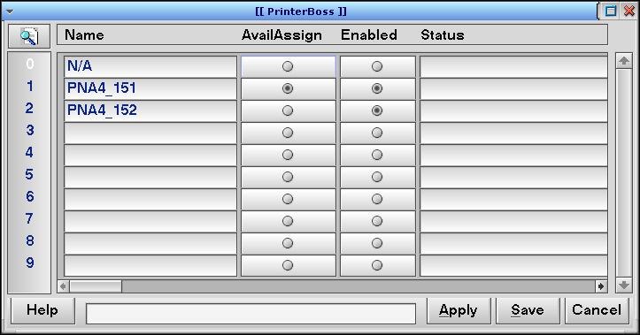

Name
Type: String. This is the name of the printer. In the event a printer is not in service then the String will be listed in the pDown Printer column.

AvailAssign
Type: 36 (Boolean). The printer can be assigned labels. If AvailAssign is false then the printer is not considered in service.

Enabled
Type: 36 (Boolean). The printer is enabled. If Enabled is false then the printer is not considered in service.

PrintLine
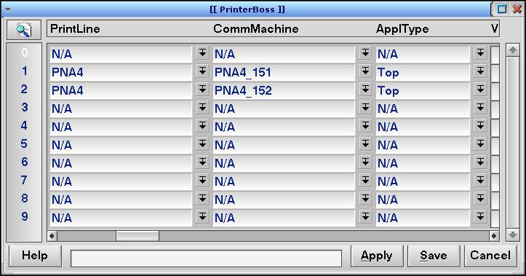
Type: POP-UP SELECTION UNIQUE, PopUpMenu = ’PrintApplyLine’. The row index of the Print and Apply Line, which this printer is assigned to. The PrintApplyFallback menu PA Name column will have a matching value.

PrinterErrorIn
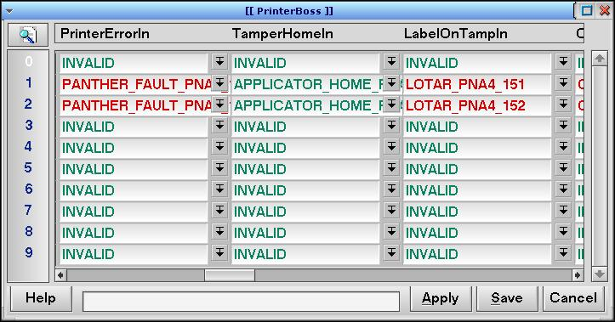
Type: POP-UP SELECTION UNIQUE, PopUpMenu = ‘Conveyor’. Contains the I/O location that indicates a printer fault. Used to determine if a printer is out of service due to a problem with the printer.

PrintApplyLine
The PrintApplyLine menu defines the configuration for a Print and Apply Line.

Name
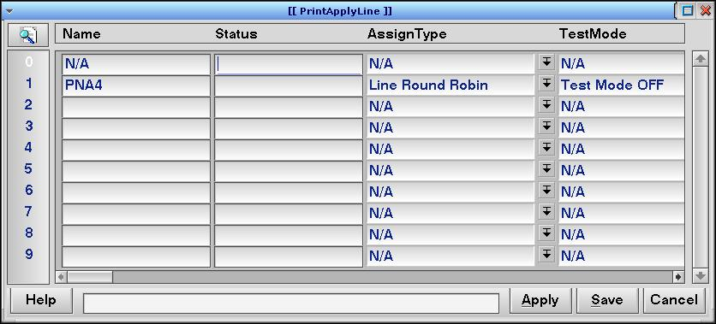
Type: String. This is the name of the Print and Apply Line.

ControlMachine
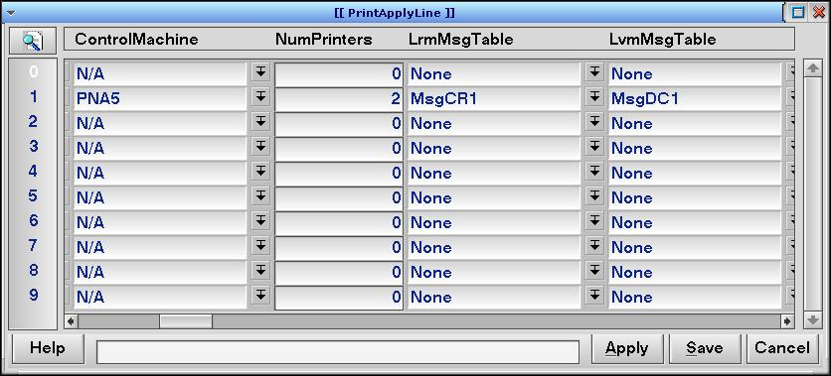
Type: POP-UP SELECTION UNIQUE, PopUpMenu = ‘Machine’. This column contains the name of the machine that is controlling the Print and Apply Line. The Print and Apply Fallback code will not control configurations for Print and Apply Lines that are not controlled by the current machine.

NumPrinters
Type: INTEGER. This is the number of PrinterBoss(es) connected to the Print and Apply Line. The Print and Apply Fallback code will verify that there are fallback configurations for the number of printers.

New Gapper
The New Gapper is a logic device that consists of two conveyor belts. A gap or pitch can be created by stopping the first belt and running the second belt. See <\\Readingfs1\Software\_DOCS\FortnaPlus_Documentation\NewGapper Module.pdf> for a detailed description of the New Gapper’s operation.

Name
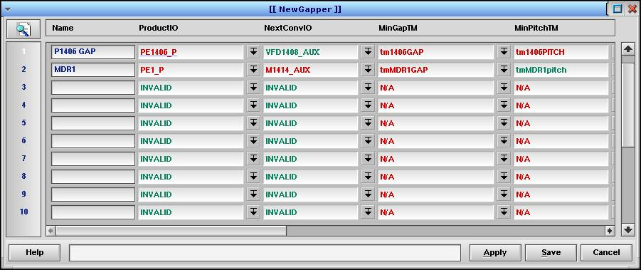
Type: STRING. This is the name of the New Gapper. The New Gapper column in the Print and Apply Fallback menu will show this name.

MinGapTM
Type: POP-UP SELECTION UNIQUE, PopUpMenu=’timemenu’. This is the minimum gap tail to nose for the containers. The MinGapTM will be started once the end of the container unblocks the photo-eye. The next container will be held until the MinGapTM timer expires. The Print and Apply Fallback code will write the number of tick specified in the Gap Time column to the timer in the MinGapTM column.

MinPitchTM
Type: POP-UP SELECTION UNIQUE, PopUpMenu=’timemenu’. This is the minimum pitch nose to nose for the container. The MinPitchTM will be started once the container begins to move. The next container will be held until the MinPitchTM timer expires. The Print and Apply Fallback code will write the number of tick specified in the Pitch Time column to the timer in the MinPitchTM column.

Servo Gapper
The Servo Gapper is a variable speed belt that feeds a fixed speed belt. The Servo Gapper can control spacing between containers by varying the speed of the induct belt. The control of the Servo Gapper has two modes digital and analog.
The digital mode controls the speed using 3 I/O lines. FastDigIO, MedDigIO, and StopDigIO.
For the definition of the Servo Gapper fields see \\Readingfs1\Software\_DOCS\AdminStuff\Rel8.0\Version 8 Misc Modules.doc section 2.4.1.

Name
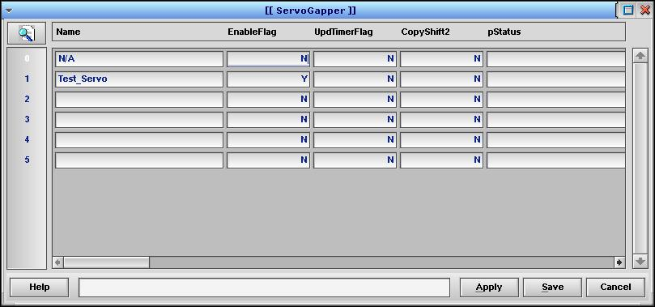
Type: STRING. This is the name of the Servo Gapper. This name will be displayed in the Servo Gapper column.

EnableFlag
Type: BOOLEAN INTEGER (Y/N). Enables or disables the Servo Gapper. The Print and Apply Fallback menu will indicate a configuration error if the EnableFlag is not set to Y in the Servo Gapper menu.

MinTicks
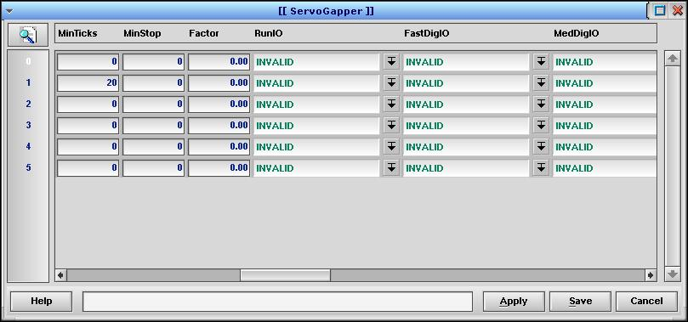
Type: INTEGER. This is the gap or pitch in ticks. The Print and Apply Fallback code will set this field based on the number of printers available.

MinStop
Type: INTEGER. If the gap between containers, in ticks, is less than or equal to MinStop stop the induct belt. I think.

Factor
Type: DOUBLE. Unknown

PitchFlag
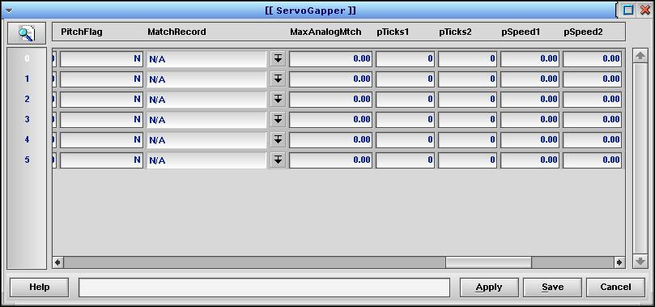
Type: BOOLEAN INTEGER (Y/N). Controls if the MinTicks column is treated as pitch (Y) or gap (N). The Print and Apply Fallback code will set MinTicks from the Gap Ticks column if PitchFlag is set to N and MinTicks will be set from the Pitch Ticks column if PitchFlag is set to Y.

MatchRecord
Type: POP-UP SELECTION UNIQUE, PopUpMenu=’SpdControl’. Used to match the speed of a conveyor section. The gets the SpdControl’s OffPercent and sets the ServoGapper’s MaxAnalog field to the MaxAnalogMtch * OffPercent. Are we setting two conveyors to the same speed?

File Structure
The Print and Apply Fallback code will be implemented in the PAFallback.c and PAFallback.h file in the INC directory. The INC directory is to be used for code targeted to the base project and shared across all clients. The SOURCE directory is to be used for client specific projects. It is expected the feature will be used by all clients.

PrintApplyFallback Process
The Print and Apply Fallback code operates in the context of the fpctrl process. Internally to the code we also refer to the called subroutines as processes. To enable the running of the Print and Apply Fallback process the process is added to the proctablectrl table using the iniproc_ctrl API with the name “PAFB CTRL”. It must be added in the context of the fpctrl and fpsort process. I’m not sure why it needs to be added to the fpsort process other then I can’t make it work. There is a security table that needs to be updated. The security table is located at RUN/FORTNA/ctrlprocnames.asc. The line PAFB CTRL~100~ needs to be added. After FortnaPlus Control is started the “Configuration Menu…->Standard Controls…->Batches” menu needs to be configured to run the Print and Apply Fallback process.
The configuration is
- File_Name = PrintApplyFallback
- Description = Print Apply Fallback
- HowOften = 1
- Increment = INVALID
- Type = Count
- Process = CTRL
- InternalProc = blank
- InternalProcCtrl = PAFB CTRL
- Machine = CP2
- All Machines = N
- DoFile = N

Error Reporting

General Architecture

Startup Logs
Startup information is logged to the following files in the “../LOGS” directory where the “./fortna” executable was run. Each log is rewritten on each start of the fortna executable.
- <machine>_fortna.log
- <machine>_fpctrl.log
- <machine>_fpgui.log
- <machine>_fpserv.log
- <machine>_fpsort.log
Each log covers a process in the fortna executable.

Runtime Logs
Runtime information is logged to the following files by default in the ../LOGS directory.
- <machine>CTRL.<day>
- <machine>GUI.<day>
- <machine>MAIN.<day>
- <machine>SERV.<day>
- <machine>SORT.<day>
The logging information is appended to each file.

Computer System

System Architecture
Initial development will be done using QNX 6.4.1 hosted under VMWare with 2 processors, 8 GB of hard disk space, and 1 GB of RAM.

Real-time Performance
Testing on a 3.4 GHz processor shows an average runtime of 2.5 us and a high runtime of 13 us for Print and Apply Fallback processing.

Support
TDB

Deployment and Validation Plan

Intent
The intent of the test plan is to validate the Print and Apply Fallback configuration code operates as expected and can be deployed at a Client’s site. The testing will consist of simulation and physical equipment if it is available.

Print and Apply Simulation Setup
Initial testing will simulate a Print and Apply Line. The instructions for simulating and testing a Print and Apply Line can be found in PA_TestPlan.doc. The following sections document where the configuration menus in the PA_TestPlan.doc can be found and if other modification where required. In many cases the name of the configuration does not match the name in the menu structure or the actual name of the menu.

Machine Menu
The Machine menu is located under Configuration Menu…->Communication Utilities…->Machine.

MsgMap Menu
The MsgMap menu is located under Configuration Menu…->Communication Utilities…->Message Map.

Configure I/O
The Configure I/O menu named IO_Configuration is located under Configuration Menu…->Communication Utilities…->IO Configure or Configuration Menu…->IO Utilities…->IO Configure

Conveyor I/O Menu
The Conveyor I/O menu named Parts_Menu is located under Configuration Menu…->IO Utilities…->IO Conveyor.

Batches Configuration
The Batches Configuration menu named Batches is located under Configuration Menu…->Standard Controls…->Batches. I believe DOSCAN is now DO SCANS.

Sorter Configuration
The Sorter Configuration menu named Sorters is located under Configuration Menu…->Sorter Utilities…->Shifter Configurations.

Induct Point Menu
The Induct Point menu named Sorter Inpoints is located under Configuration Menu…->Sorter Utilities…->Induct Points

Divert Point Menu
The Divert Point menu named Sorter Outpoints is located under Configuration Menu…->Sorter Utilities…->Divert Points

Update Points
The Sorter Update menu named Sorter Updates is located under Configuration Menu…->Sorter Utilities…->Update Points.

ScanStat Configuration
The Scan Stat Configuration named Scanner Stats is located under Configuration Menu…->Communication Utilities…->Scanstat Config. PA scanstat maybe PA (ScanProcess).

Print Apply Line
The Print Apply Line menu named PrintApplyLine is located under Configuration Menu…->PrintApply Utilities->Print Apply Line. Mtr Stop Bit is MtrBIT, PrintLineSpdMtr is PrintLineSpdCtrl, and Speed Stop Bit is SpeedBit.

Printer Belt Configuration
The Printer Belt menu named PrintBelt is located under Configuration Menu…->PrintApply Utilities->Printer Belt.

Height/Width/Length Configuration
The Height/Width/Length Configuration named HeightWidth is located under Configuration Menu…->PrintApply Utilities->Height Width Config.

Printer Configuration
The Printer Configuration menu named PrinterBoss is located under Configuration Menu…->PrintApply Utilities->Printer Configuration. Printer Belt should be Line1 not PA1.

Printer Update Point Configuration
The Update Pnts menu named PrinterUpdPnts is located under Configuration Menu…->PrintApply Utilities->Update Pnts.

Test Config Line
The Test Config Line Menu named TestConfig is located under Configuration Menu…->PrintApply Utilities->TestConfig.

Test Config Printer
The Test Config Printer menu named TestCnfgPrt is located under Configuration Menu…->PrintApply Utilities->Test Config Printer

Label Configuration
The Label Configuration menu named LabelTemplates is located under Configuration Menu…->PrintApply Utilities->Label Configuration.

Print and Apply Simulation Operation.

Shifters Window
After completing the setup of the Print and Apply Line simulation, a graphical representation can be displayed in the Shifters Window. The Shifters Window can be opened by going to Configuration Menu…-> Shifter Configurations->Display Graphical Shifters. You should see the following window.
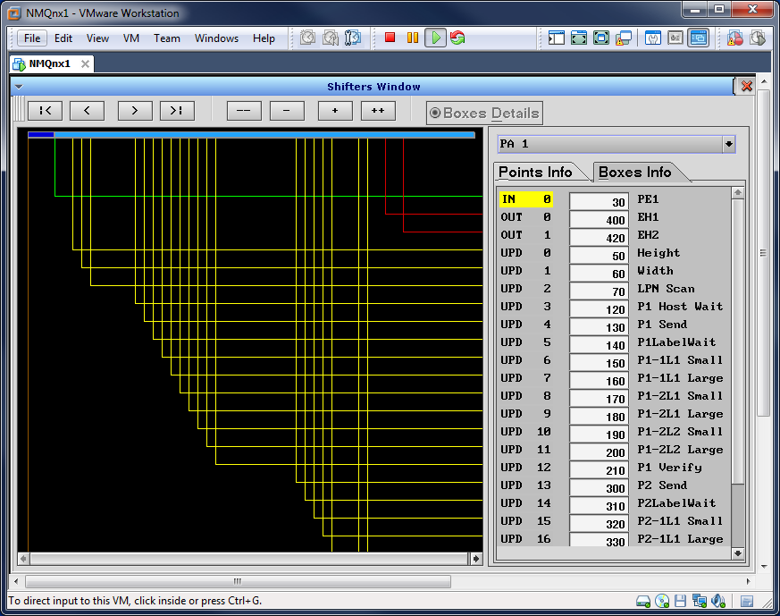

Client Responsibilities

Network Access
TDB

Deployment Strategy
TDB

Execution Plan
TDB

Verification and Validation Matrix
TDB

